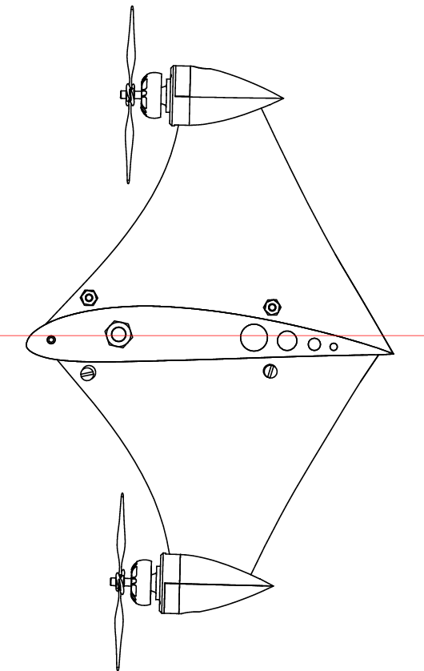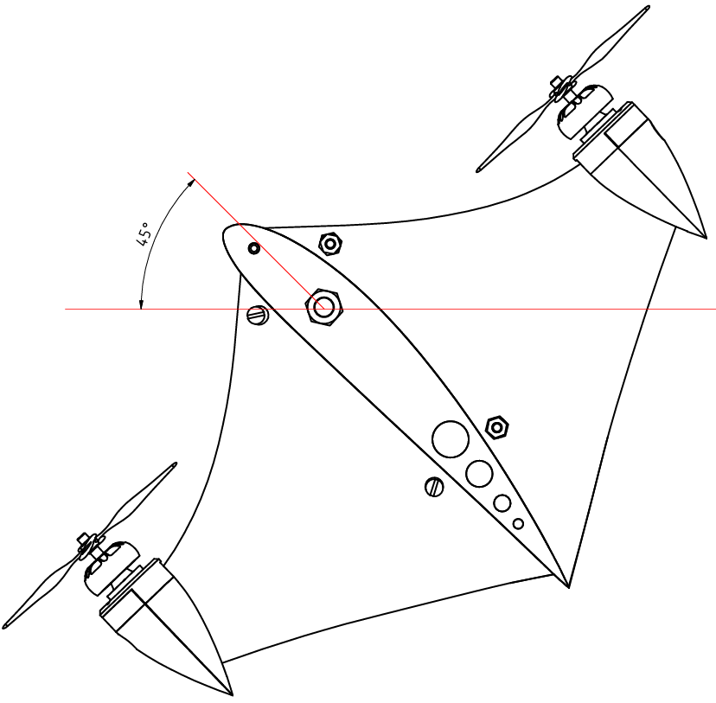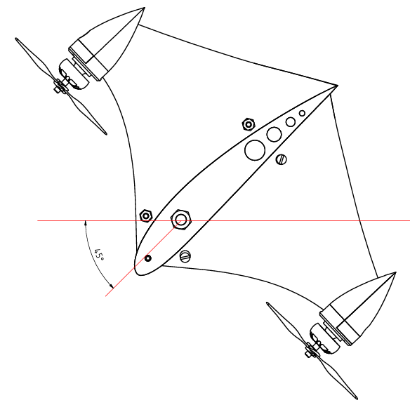

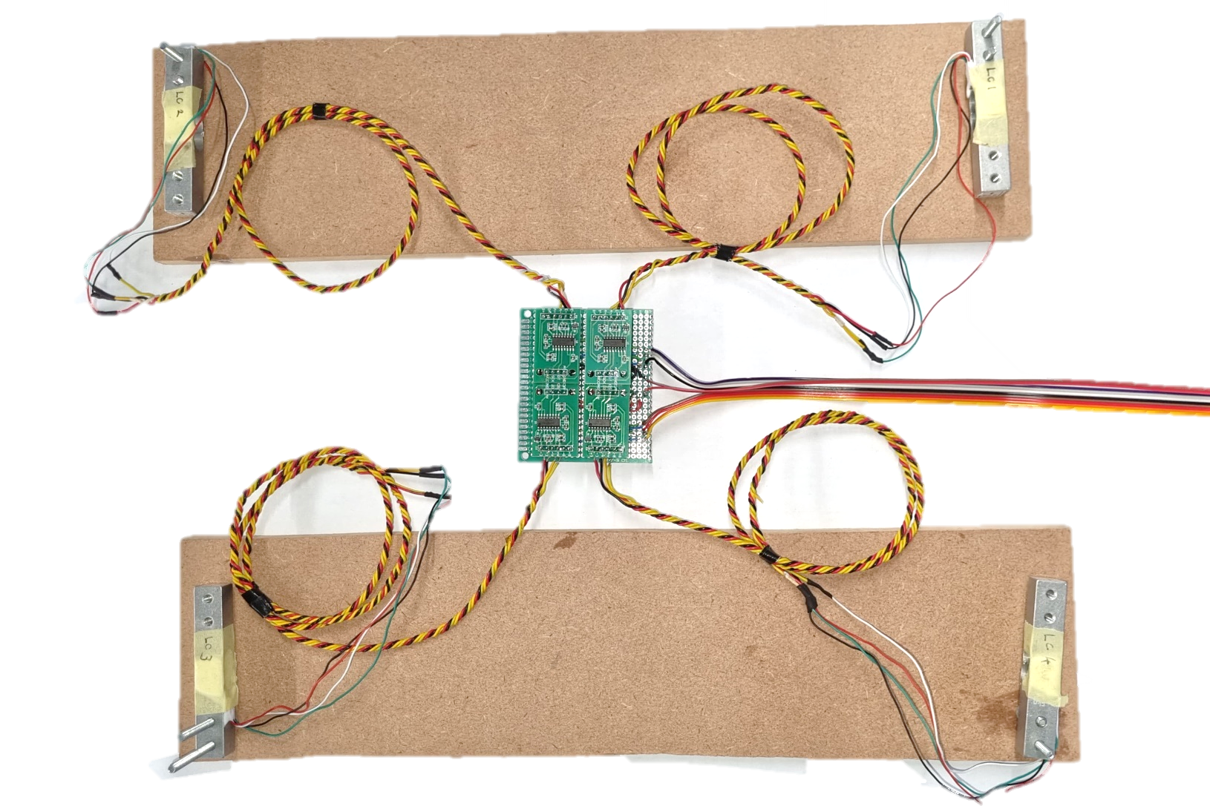

Data Lines

Load Cell 4

Load Cell 3

HX711

Module

Load Cell 2

Load Cell 1

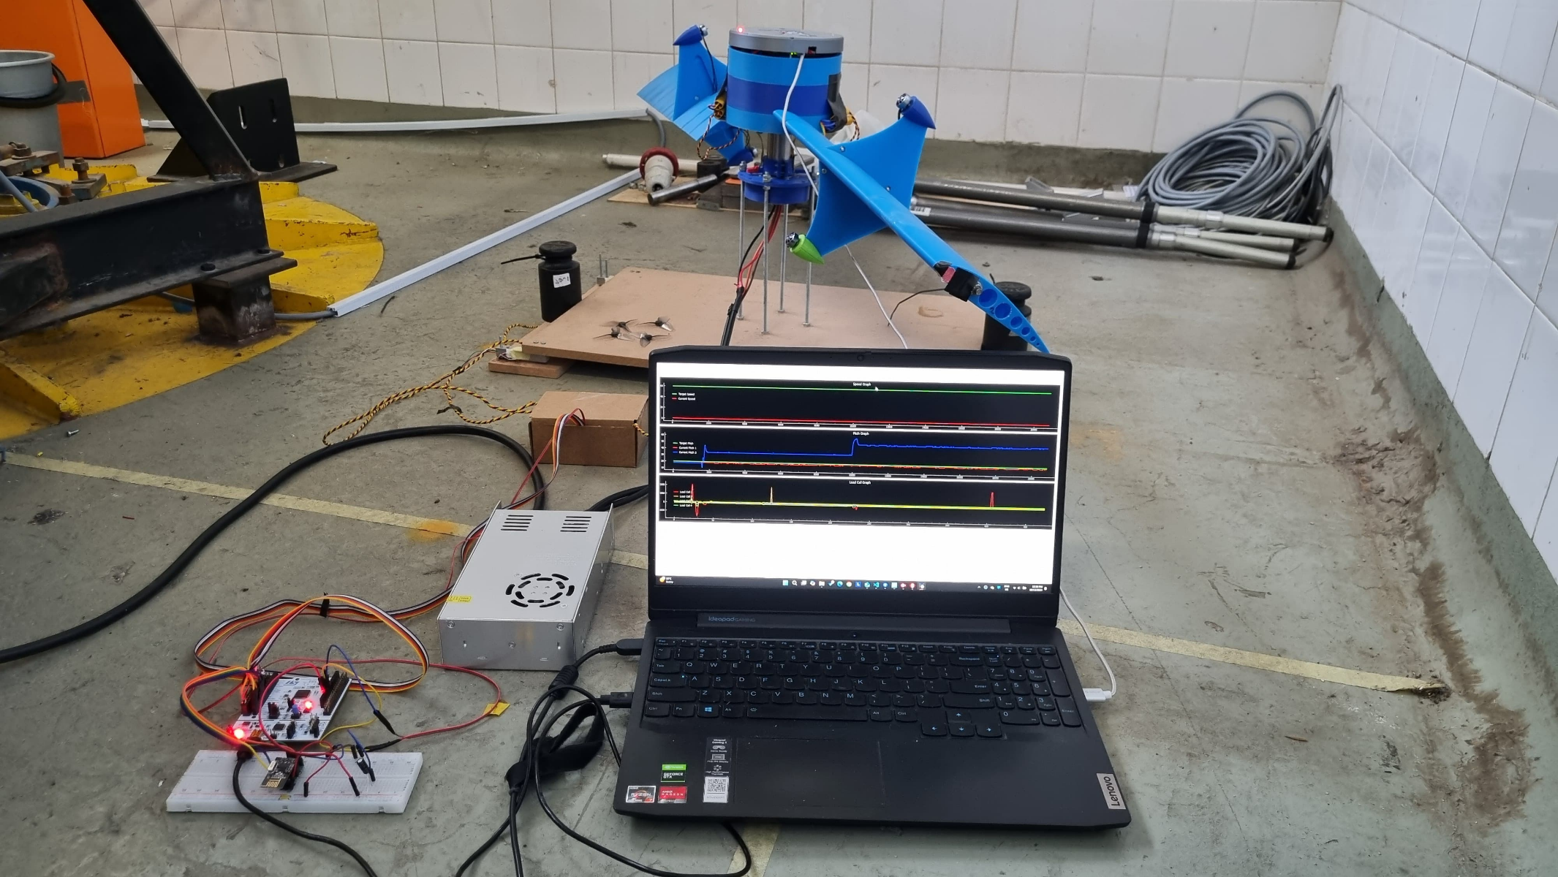

NRF24L01+ Module

Aircraft

Computer

Power Supply

Test Bench

Nucleo F411

HX711 Module





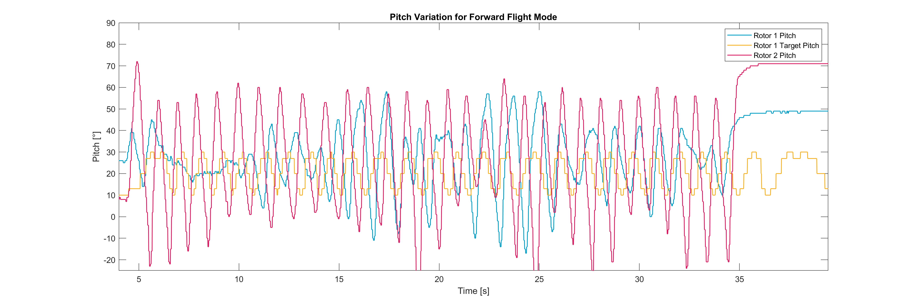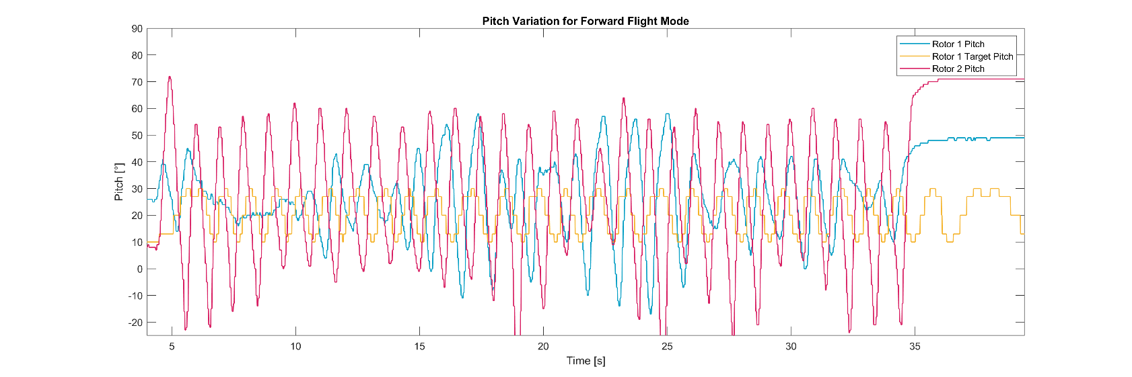

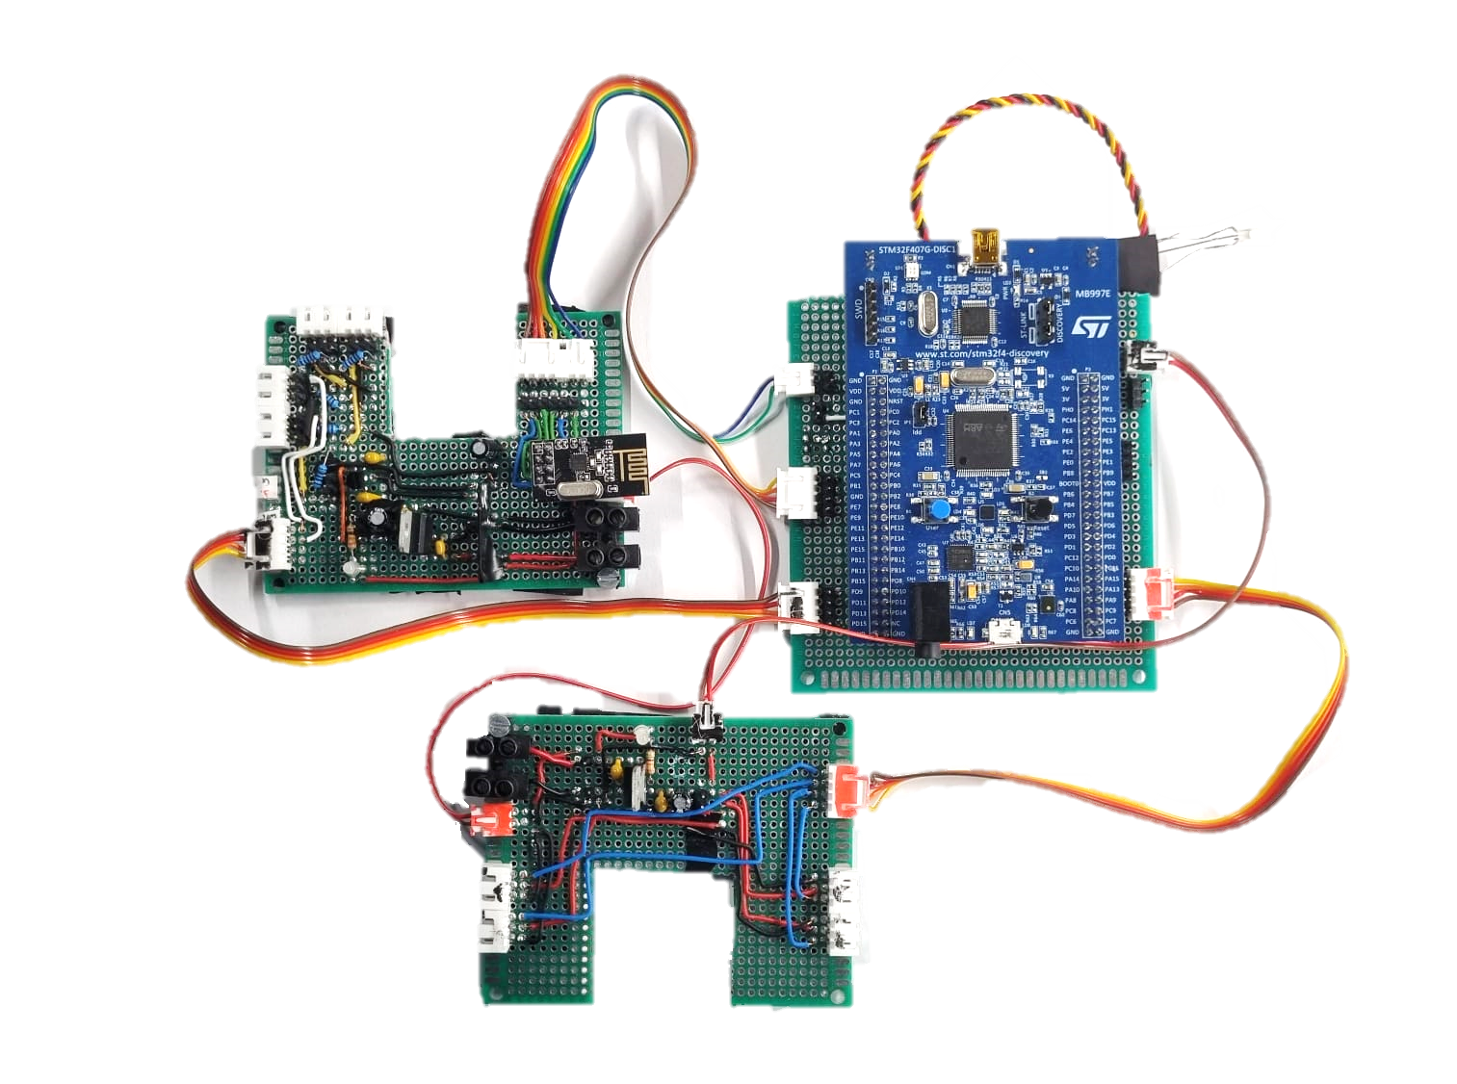

5 V Regulator

5 V Regulator

5 V Regulator

STM32F407VG Discovery Kit

Indicator LED

NRF24L01+ Module

Data Lines

Microcontroller 5 V Power Supply

PWM Motor Signal Data Lines

Potentiometer and Hall Effect Sensor Data Lines

Rotor 2 Top Motor

Rotor 2 Bottom Motor

Rotor 1 Bottom Motor

Rotor 1 Top Motor

12 V Input

5 V Regulator

3.3 V Regulator

Potentiometer Connections

Hall Effect

Sensor Connections

NRF24L01+ Module

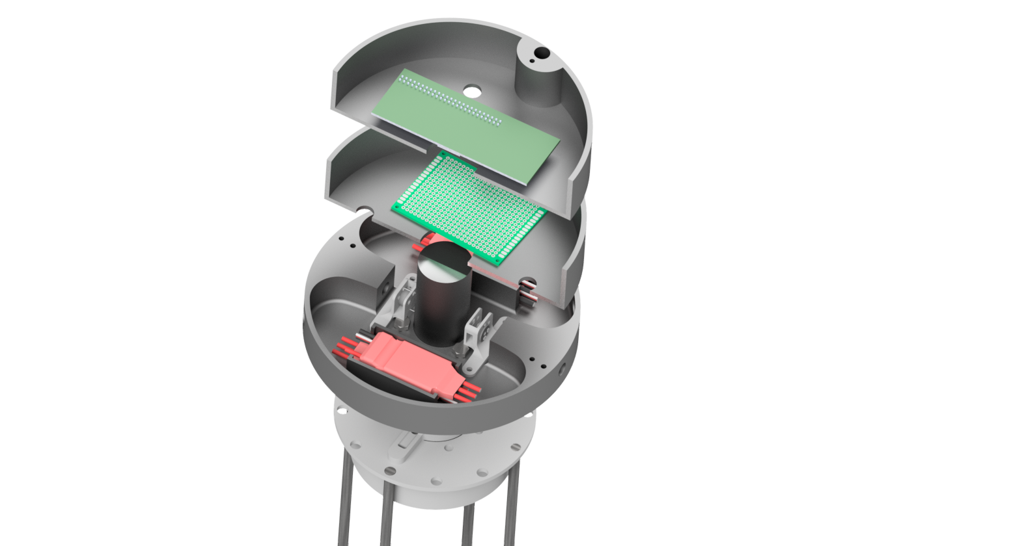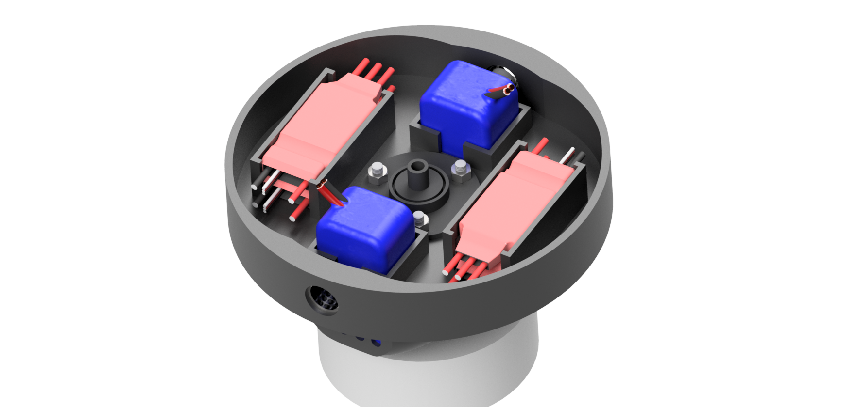

Hall Effect Sensor

ESC

Potentiometer

Power Slip Ring

Electronics

Microcontroller

Bushing

Battery

ESC

Data Slip Ring

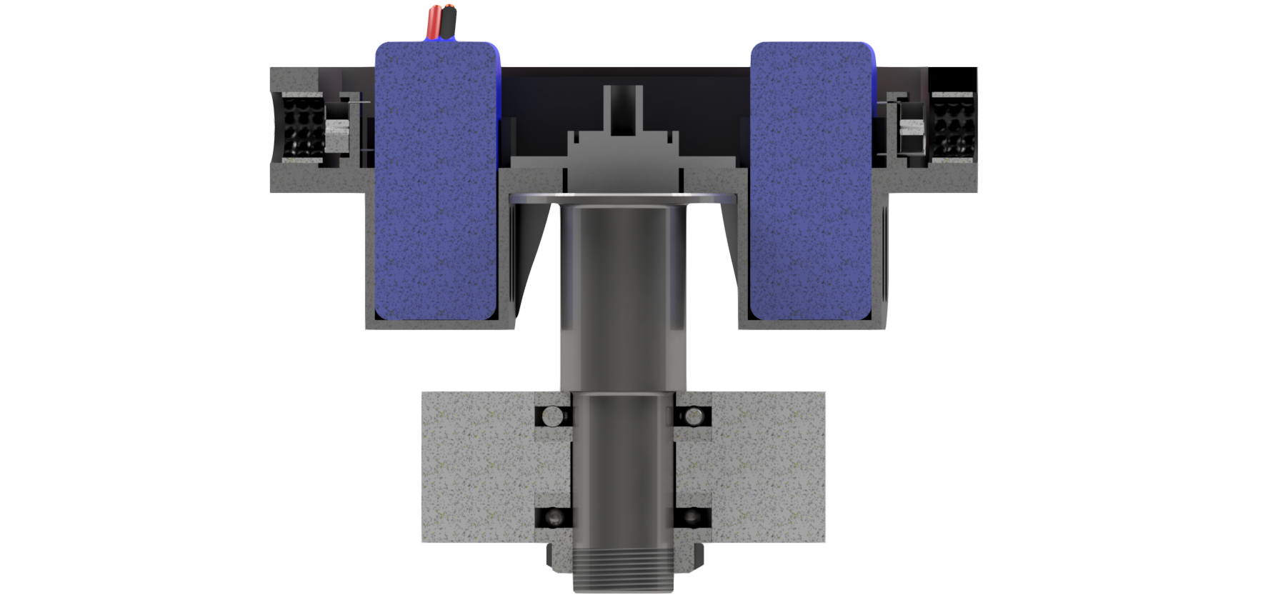

Lock Nut

Potentiometer

Bushing

Battery Casing

Support Shaft

Main Body

Thrust Bearings

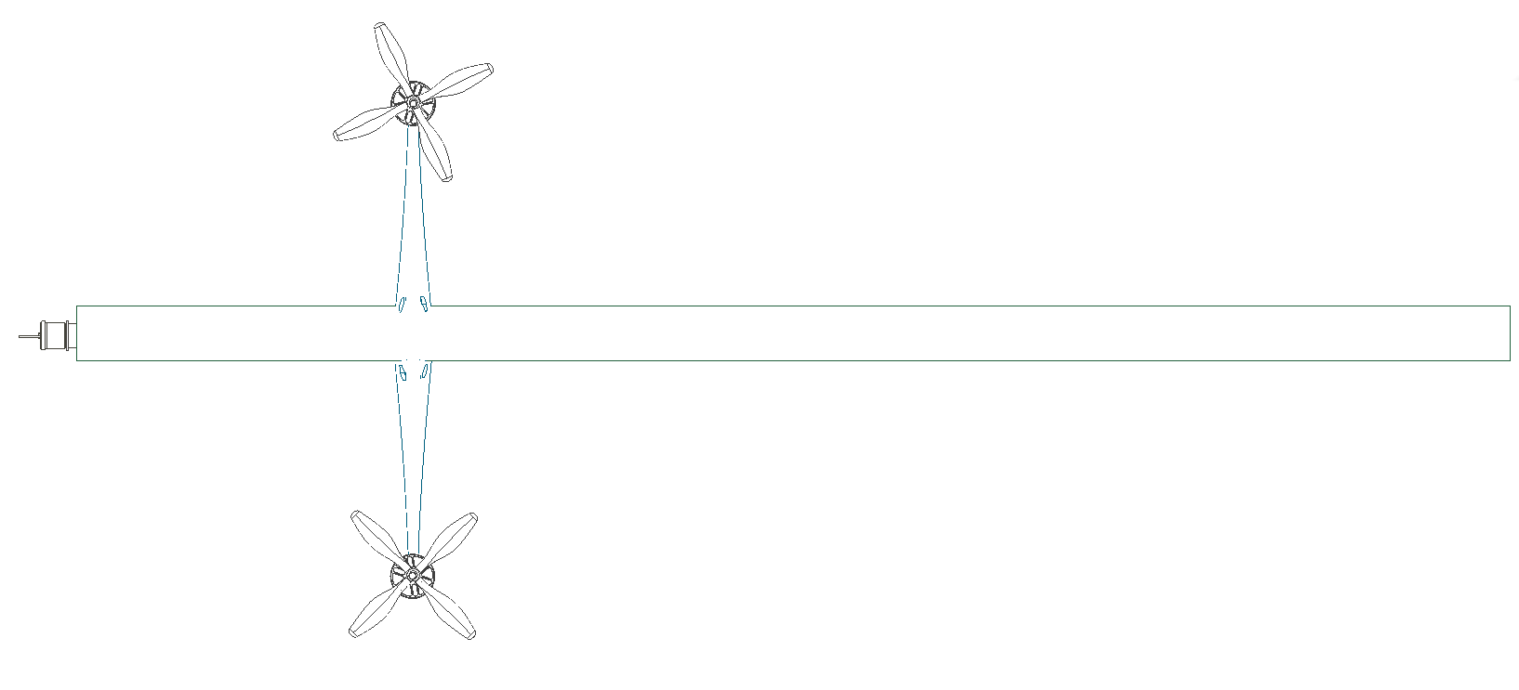

FR2

FR1

FL(x)

FRW

FRL

FM2

FM1

W(x)

LB

LA

LC

